Exercise 1: Control Structures in PL/SQL

BY:- Shubham Sangram Bej

Aim
To understand and implement PL/SQL control structures such as loops, conditional statements, and cursor-based iteration by solving real-world banking scenarios, including interest rate updates, VIP customer identification, and loan reminder generation.

Theory
PL/SQL (Procedural Language/Structured Query Language) is Oracle's procedural extension to SQL that allows developers to combine SQL statements with programming constructs such as variables, loops, conditions, cursors, and exception handling.
Control structures in PL/SQL are used to control the execution flow of a program. They make database programs more efficient by enabling repetitive operations, conditional execution, and record-by-record processing.
The commonly used control structures are:
- IF-THEN and IF-THEN-ELSE statements
- CASE statements
- LOOP
- WHILE LOOP
- FOR LOOP
In this exercise, cursors are used to iterate through records in database tables, while IF conditions determine whether a customer satisfies the required business conditions.

Scenario 1

Problem Statement
The bank wants to apply a discount to loan interest rates for customers above 60 years old. Write a PL/SQL block that loops through all customers, checks their age, and if they are above 60, applies a 1% discount to their current loan interest rates.

Algorithm
- Declare a cursor to retrieve customer and loan details.
- Calculate the age of every customer using the Date of Birth.
- Traverse all customer records using a FOR loop.
- Check whether the customer's age is greater than 60 years.
- If true, reduce the loan interest rate by 1%.
- Display a message showing the updated interest rate.
- Commit the changes.

PL/SQL Program
DECLARE
V_AGE NUMBER;
BEGIN
FOR REC IN (
SELECT
C.CUSTOMERID,
C.NAME,
C.DOB,
L.LOANID,
L.INTERESTRATE
FROM
CUSTOMERS C
JOIN LOANS L ON C.CUSTOMERID = L.CUSTOMERID
) LOOP
V_AGE := FLOOR(MONTHS_BETWEEN(SYSDATE, REC.DOB) / 12);
IF V_AGE > 60 THEN
UPDATE LOANS
SET
INTERESTRATE = INTERESTRATE - 1
WHERE
LOANID = REC.LOANID;

DBMS_OUTPUT.PUT_LINE(REC.NAME
|| ' (Age: '
|| V_AGE
|| ') -> Interest Rate Updated to '
||(REC.INTERESTRATE - 1) || '%');

END IF;

END LOOP;

COMMIT;
END;
/

Output
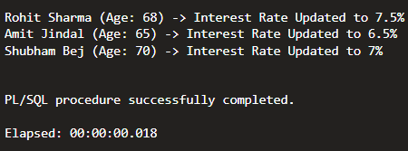

Updated Loans Table

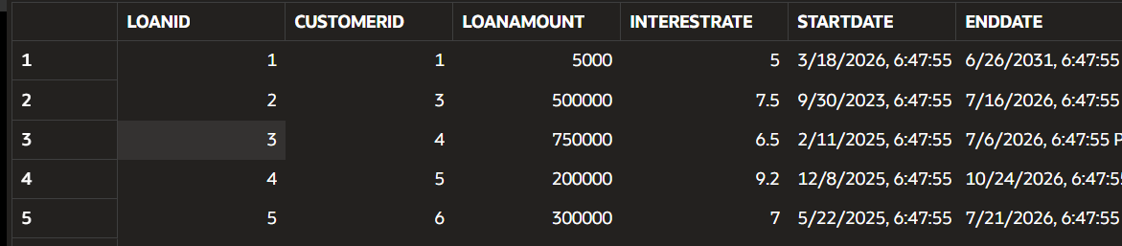

Scenario 2

Problem Statement

A customer can be promoted to VIP status based on their balance. Write a PL/SQL block that iterates through all customers and sets a flag IsVIP to TRUE for those with a balance over $10,000.

Algorithm
- Declare a cursor to retrieve all customer records.
- Traverse each customer using a FOR loop.
- Check whether the customer's balance is greater than ₹10,000.
- If the condition is satisfied, update the IsVIP field to 'Y'.
- Display the customer name and confirmation message.
- Commit the changes.

PL/SQL Program
BEGIN
FOR REC IN (
SELECT
CUSTOMERID,
NAME,
BALANCE
FROM
CUSTOMERS
) LOOP
IF REC.BALANCE > 10000 THEN
UPDATE CUSTOMERS
SET
ISVIP = 'Y'
WHERE
CUSTOMERID = REC.CUSTOMERID;

DBMS_OUTPUT.PUT_LINE(REC.NAME || ' promoted to VIP.');
END IF;
END LOOP;

COMMIT;
END;
/

Output

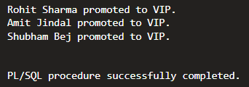

Updated Customer Table

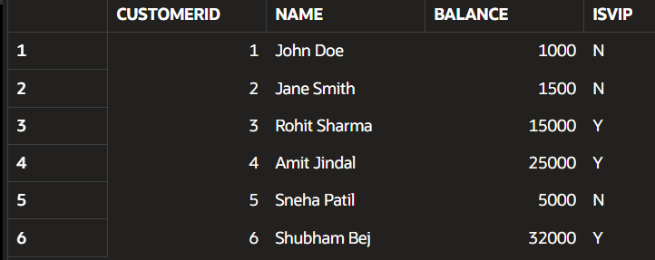

Scenario 3

Problem Statement
The bank wants to send reminders to customers whose loans are due within the next 30 days. Write a PL/SQL block that fetches all loans due in the next 30 days and prints a reminder message for each customer.

Algorithm
- Declare a cursor to retrieve loan records due within 30 days.
- Iterate through each loan record.
- Display the customer name and loan due date.
- Generate reminder messages using DBMS_OUTPUT.PUT_LINE().

PL/SQL Program
BEGIN
FOR REC IN (
SELECT
C.NAME,
L.LOANID,
L.ENDDATE
FROM
CUSTOMERS C
JOIN LOANS L ON C.CUSTOMERID = L.CUSTOMERID
WHERE
L.ENDDATE BETWEEN SYSDATE AND SYSDATE + 30
) LOOP
DBMS_OUTPUT.PUT_LINE('Reminder: Dear '
|| REC.NAME
|| ', your Loan ID '
|| REC.LOANID
|| ' is due on ' || TO_CHAR(REC.ENDDATE, 'DD-MON-YYYY'));
END LOOP;
END;
/

Output
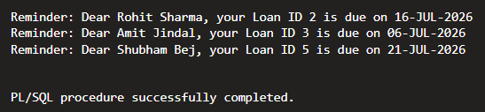

Concepts Used
- PL/SQL Blocks
- Variables
- FOR LOOP
- IF Statement
- Cursor
- UPDATE Statement
- COMMIT
- DBMS_OUTPUT
- Date Functions
- Conditional Processing

Conclusion
This exercise demonstrated the practical use of PL/SQL control structures in a banking application. Cursor-based iteration, conditional statements, and loops were successfully implemented to automate common banking operations such as applying loan discounts, identifying VIP customers, and generating loan reminders. These techniques improve automation, reduce manual effort, and enhance the efficiency of database applications.

Result
The PL/SQL programs for applying loan discounts, updating VIP status, and generating loan reminders were executed successfully, and the expected outputs were obtained.

